INNOVA JUNIOR COLLEGE
JC 2 PRELIMINARY EXAMINATION 2
in preparation for General Certificate of Education Advanced Level
Higher 2

CANDIDATE
NAME

CLASS INDEX NUMBER

BIOLOGY  Paper 2 Core Paper  Additional Materials: Answer Paper  Cover Page | 9648/02, 9747/02  2 September 2010  2 hours

READ THESE INSTRUCTIONS FIRST
For Examiner’s Use
Section A
1 | 9
2 | 14
3 | 15
4 | 12
5 | 8
6 | 6
7 | 6
8 | 10
Section B
9 / 10 | 20
Total | 100
Grade

Write your name and class on all the work you hand in.
Write in dark blue or black pen on both sides of the paper.
You may use a soft pencil for any diagrams, graphs or rough working.
Do not use staples, paper clips, highlighters, glue or correction fluid.

Section A
Answer all questions.

Section B
Answer any one question.

At the end of the examination, fasten all your work securely together.
The number of marks is given in the brackets [ ] at the end of each question or part question.

This document consists of 20 printed pages.
 | Innova Junior College | [Turn over

Section A
Answer all questions.

1 | Enzymatic browning is one of the most important colour reactions that affect fruits. Cut apples turned brown after exposure to air within minutes. This browning reaction is catalysed by the enzyme polyphenol oxidase (PPO) which is abundant in the flesh of the apples. PPO converts iron-containing phenol compounds in the presence of oxygen to melanin in a series of polymerization reactions.  Fig. 1.1 shows the structure of the PPO enzyme.  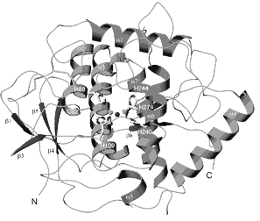  Fig. 1.1
 | (a) | With reference to Fig. 1.1, describe the structure of the PPO enzyme.
 |  |  |  |  |  |  | [3]
 | (b) | Suggest the role of PPO in melanin synthesis in apples.
 |  |  |  |  |  |  | [2]
Fig. 1.2 shows the results of tests to determine the optimum temperature for the activity of PPO.

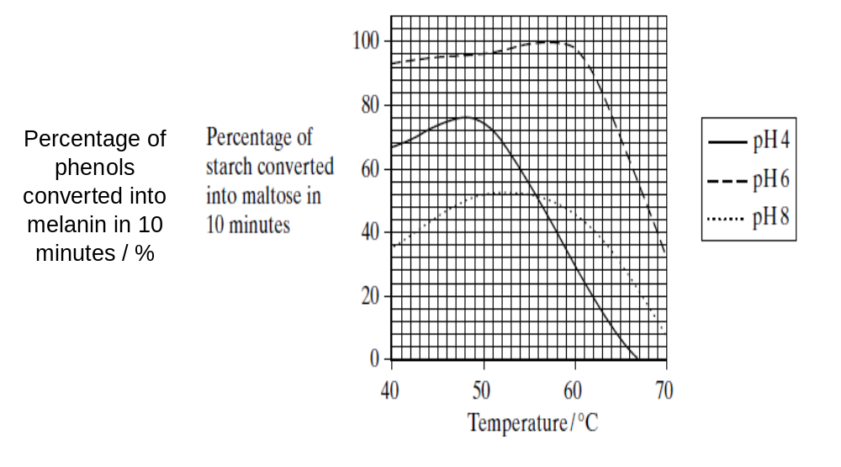

Fig. 1.2

 | (c) | With reference to Fig. 1.2,
 | (i) | state the optimum pH and temperature for the enzyme PPO.
 |  | pH
 |  | temperature |  |  |  | [1]
 | (ii) | account for the curve at pH 8.
 |  |  |  |  |  |  | [3]
 | [Total: 9]

2 | Fig. 2 is an electron micrograph showing T4 bacteriophages invading a bacterium.  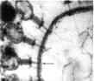  A  B  C  Fig. 2
 | (a) |  | Explain what is meant by the term bacteriophage.
 |  |  |  |  |  | [2]
 | (b) |  | Identify the structures labelled A, B and C.
 |  |  | A
 |  |  | B
 |  |  | C |  | [3]
 | (c) |  | Suggest how a bacteriophage attaches to the correct host cell.
 |  |  |  |  |  | [2]
 | (d) |  | Explain how the bacteriophage DNA enters the host bacterial cell.
 |  |  |  |  |  | [3]
 | (e) |  | Outline the main events of the lytic cycle following the entry of the phage DNA into the host cell.
 |  |  |  |  |  | [3]
 | (f) |  | Suggest one possible use which could be made of bacteriophages.
 |  |  |  |  |  | [1]
 |  |  | [Total: 14]
3 | The bacterium, Escherichia coli (E. coli), can use either glucose or lactose as a respiratory substrate.  When grown in a medium containing lactose only, the genes coding for the enzymes required to utilise lactose are switched on.  These genes are located together in the lac operon as shown in Fig. 3.1  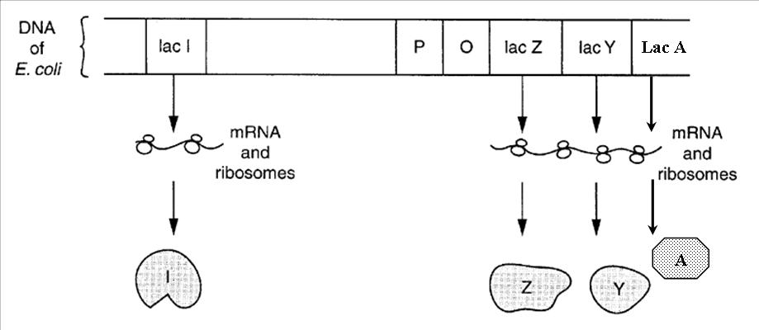  Fig. 3.1
 | (a) | With reference to Fig. 3.1, complete the table below.

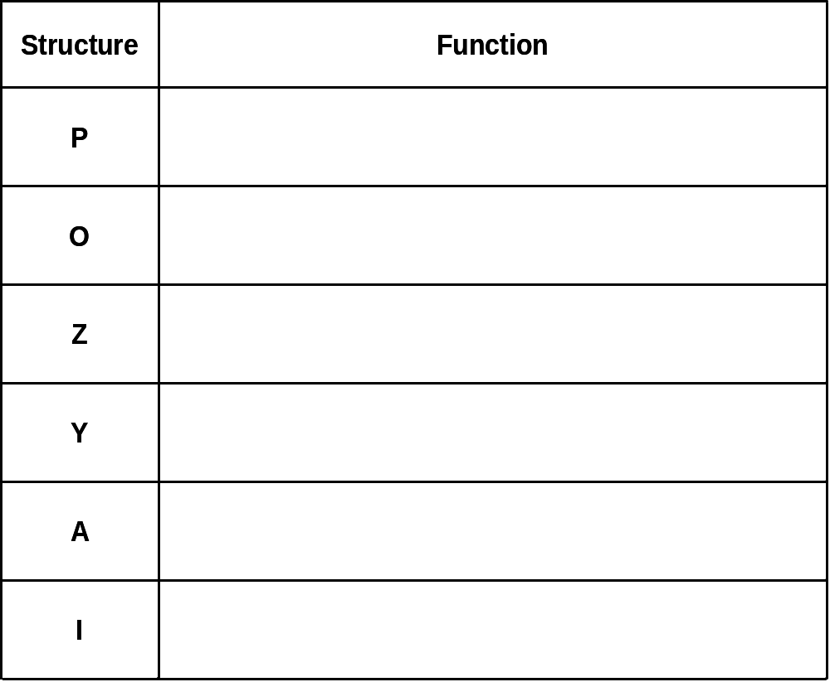

 |  | [3]
Fig. 3.2 shows a diauxic growth curve of E. coli cultured in a medium with both glucose and lactose.

Growth () of bacteria is measured in terms of optical density (OD) at wavelength of 650nm, concentration of lactose () and glucose () are measured in millimolar (mM).

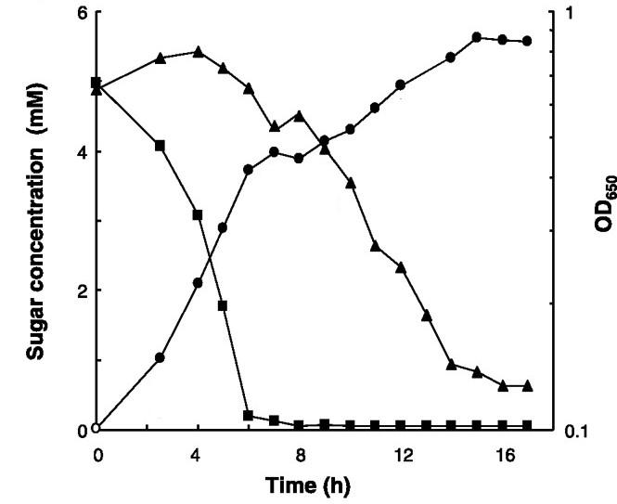

Fig. 3.2

 | (b) | With reference to Fig. 3.2, explain the bacteria growth rate
 | (i) | for the first 6 hours;
 |  |  | [3]
 | (ii) | from 6 to 8 hours;
 |  |  | [1]
 | (iii) | from 8 hours onwards.
 |  |  | [5]
 | (c) | Suggest reasons why prokaryotes regulate gene expression predominantly at the transcription level.
 |  |  | [2]
 | (d) | Suggest the biological advantage of arranging genes in operons.
 |  |  | [1]
 |  | [Total: 15]

4 | In disorders such as retinoblastoma, individuals inheriting one mutant allele of the RB1 gene can cause a predisposition to the development of eye tumours. For individuals to develop retinoblastoma, a somatic mutation in the other normal allele of the RB1 gene is necessary.
 | (a)(i) | Explain if the mutant RB1 allele causing retinoblastoma acts in a dominant or recessive manner.
 |  |  |  | [2]
 | (ii) | Suggest how somatic mutation in the normal allele can occur.
 |  |  |  | [1]
The RB1 allele codes for the RB protein (pRB) which binds to a family of transcription factors called E2F. pRB binding inactivates E2F proteins. When pRB is phosphorylated by cyclin-CDK complexes, it releases bound E2F proteins resulting in the production of proteins involved in cell cycle progression to S phase through the cell cycle checkpoint. Fig. 4.1 shows the interaction between pRB and cyclin-CDKs.

Fig. 4.1
 | (b) | Describe how a mutation in the RB1 allele results in retinoblastoma.
 |  |  | [3]
receptor tyrosine kinase | pRB and cyclin-CDKs are involved in G₁ checkpoint which regulates cell division. The accumulation of cyclinE-CDK2 and cyclinD-CDK4 is due to the presence of growth factors.  Fig. 4.2 shows the cell signalling pathway at the G₁ checkpoint involving cyclinD, cyclinE and pRB.  growth factor  ras protein  relay protein  myc gene  cytosol  nucleus  increase in cyclin D  increase in cyclin E  increase in E2F  Fig. 4.2
 | (c)(i) | Describe how the presence of growth factors influences the progression of the cell cycle.
 |  |  |  | [3]
 | (ii) | A mutation in the ras gene also brings about cancer. With reference to Fig. 4.1 and 4.2, explain why cancer is a multi-step process.
 |  |  |  | [2]
 | (iii) | State one other factor, besides the presence of growth factors, which influences the progression of the cell cycle through the G₁ checkpoint.
 |  |  |  | [1]
 |  | [Total: 12]

5 | Four different eye pigments in Drosophila are derived from the amino acid tryptophan. A simplified metabolic pathway of pigment production is shown in Fig. 5.1. Three different gene loci, V/v, C/c and B/b, are involved in this pathway, acting as shown in Fig. 5.1.  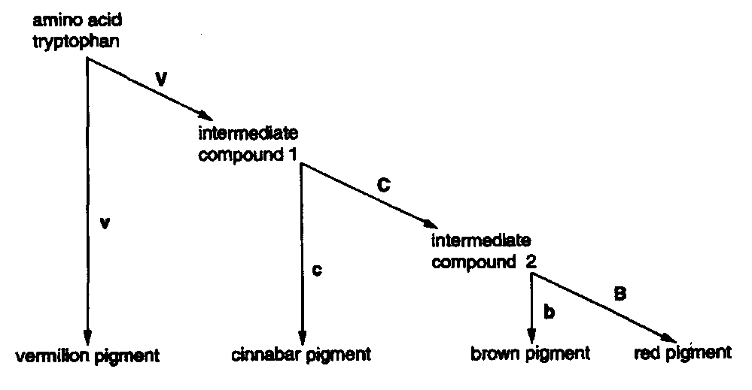  Fig. 5.1
 | (a)(i) | Using the information in Fig. 5.1, deduce the phenotypes of flies with the following genotypes: [1]
 |  | genotype | phenotype
 |  | VvCcBb
 |  | VVCCBB
 |  | VvccBB
 | (ii) | Suggest an explanation for the gene interaction in the pathway of pigment production.
 |  |  |  |  |  |  | [2]
 | Pure-breeding red-eyed flies, CCBB were crossed with pure-breeding cinnabar-eyed flies, ccbb. Both sets of flies were homozygous dominant for the V/v locus. (You need not include this locus.) The F₁ were test-crossed (backcrossed) giving 32 red-eyed, 18 brown-eyed and 50 cinnabar-eyed flies.
 | (b) | Draw a genetic diagram in the space below to show the expected genotypes and phenotypes of the offspring of this test-cross, and state the ratio of phenotypes expected. (Take care that the symbols C and c cannot be confused in your answer.)  [3]
 | (c)(i) | 36 of the cinnabar-eyed offspring in the test cross generation were pure-breeding. Perform a chi-squared test on the observed ratio of the test-cross. State the calculated χ² value. (Working is not required)  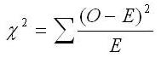
 |  | Calculated χ² value |  |  |  | [1]
 | (ii) | Using the χ² probabilities in Table 5.2, state what conclusions could be drawn from the calculated χ² value.  Table 5.2  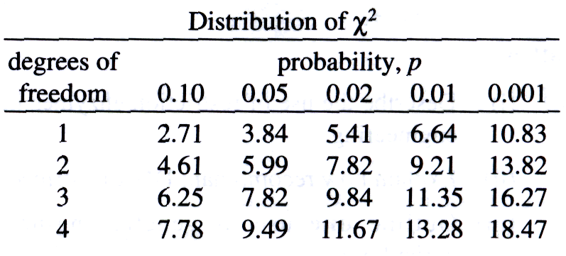
 |  |  |  |  |  |  |  | [1]
 |  | [Total: 8]

6 | A suspension of mitochondria was isolated from liver tissue. Various substances were added to the suspension at different time intervals and the amount of oxygen remaining in the preparation was monitored over some time. Fig. 6.1 shows the results as well as the times at which different substances were added.  Amount of oxygen in the preparation  Respiratory substrate added  Time A: ADP added  Time B: ADP added  Time C: ADP added  Time  Fig. 6.1
 | (a)(i) | The respiratory added was found not to be glucose. Suggest a suitable substrate to be added to the mitochondria suspension.
 |  |  | [1]
 | (ii) | Explain why glucose cannot be the respiratory substrate that was added.
 |  |  | [1]
 | (b)(i) | Explain the change in the amount of oxygen between Time A and Time B.
 |  |  | [3]
 | (ii) | Account for the shape of the graph after Time C.
 |  |  | [1]
 |  | [Total: 6]

7 | Many of the body’s pain receptors stimulate sensory neurones that terminate in the grey matter in the spinal cord. Here, they synapse with relay neurones that transmit pain information to the sensory cortex of the brain. The activity of the relay neurones is influenced by inhibitory neurones that originate in the hind brain. These neurones terminate on the synaptic bulbs of the sensory neurones just before they synapse with the relay neurones. The inhibitory neurones release the neurotransmitter enkephalin, which fits into special receptors known as opiate receptors. Opiate drugs, such as morphine, can also occupy these sites and stimulate lengthy activation of these receptors. Fig. 7 shows the arrangement of the neurones concerned with pain reception.  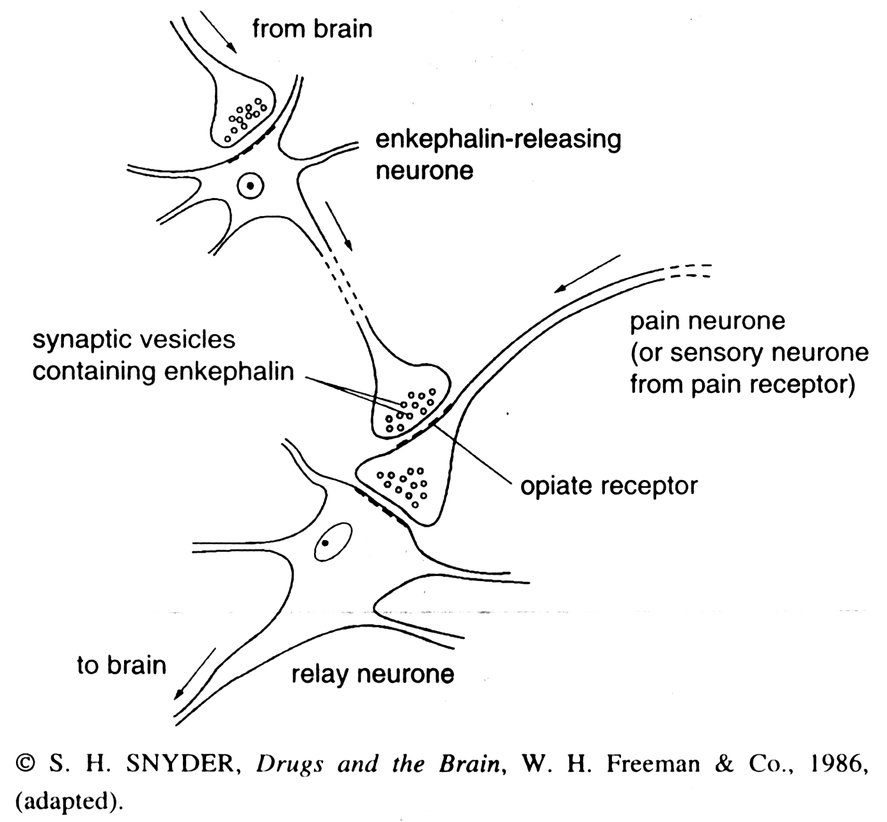  Fig. 7
 | (a) | Suggest possible mechanisms by which enkephalin-releasing neurones inhibit the passage of impulses to the brain.
 |  |  | [3]
 | (b) | Suggest why opiates stimulate lengthy activation of opiate receptors but enkephalin does not.
 |  |  | [1]
 | (c) | Explain why people addicted to opiates often experience severe pain as a withdrawal symptom.
 |  |  | [2]
 |  | [Total: 6]

8 | Table 8.1 shows the amino acid differences in the alpha haemoglobin chains between various vertebrates.

Table 8.1
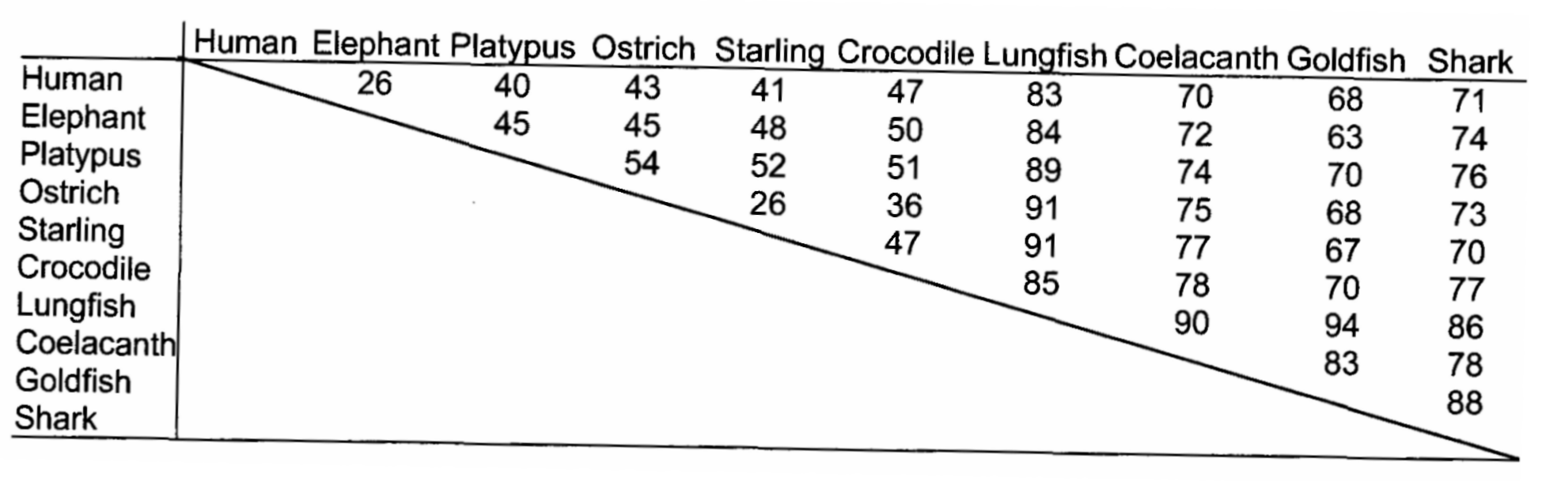

 | (a) | State what is meant by the term gene mutation.
 |  |  | [2]
 | (b) | Explain why some gene mutations do not result in a change in amino acid.
 |  |  | [3]
 | Fig. 8.2 shows a family tree based on differences between the alpha haemoglobins in Table 8.1

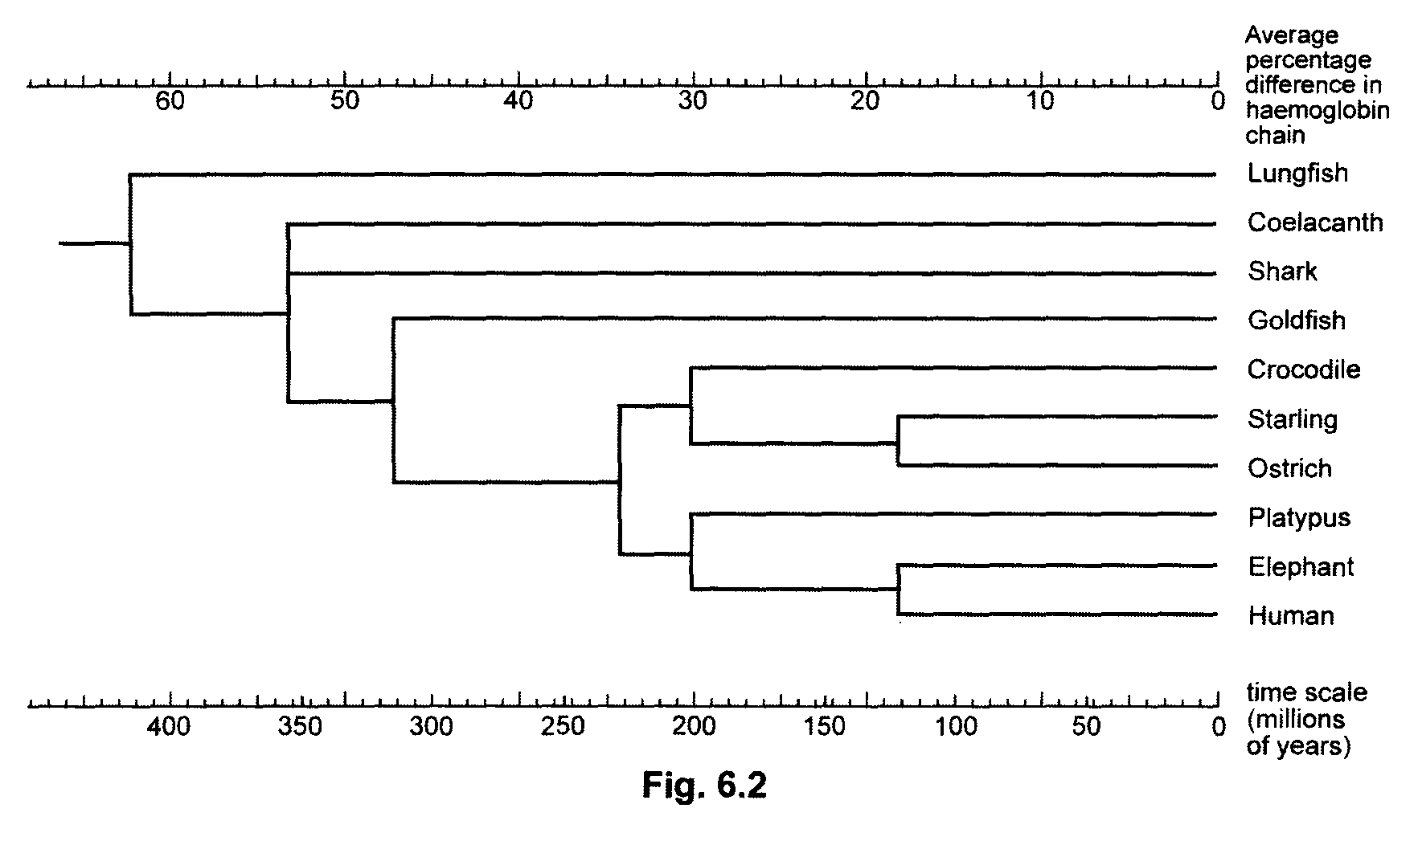

Fig. 8.2

 | (c) | Explain what direct evidence exists for the time scale in Fig.8.2.
 |  |  |  |  | [2]
 | The gene for alpha haemoglobin is carried on chromosome 16 and contains three coding sections and two non-coding sections.
 | (d) | State the name given to
 | (i) | coding sections
 | (ii) | non-coding sections |  | [1]
Also on chromosome 16, there exist duplicated but non-functional pseudogenes, that resemble the functional gene but have some defect that renders them useless.

The rate of gene mutation in non-coding sections of genes and pseudogenes is very much faster than in the coding sections of genes.

 | (e) | Suggest why the apparent rate of accumulation of gene mutations in coding sections is slower.
 |  |  |  |  | [2]
 |  | [Total: 10]

Section B
Answer any one question.

Write your answers on the separate answer paper provided.
Your answers should be illustrated by large, clearly labelled diagrams, where appropriate.
Your answers must be in continuous prose, where appropriate.
Your answers must be set out in section (a), (b) etc., as indicated in the question.

9 | (a) | Describe the structure of DNA and its organisation in a eukaryotic chromosome. [8]
 | (b) | Describe the control of gene expression in eukaryotes. [12]
 |  | [Total: 20]

10 | (a) | Explain the principles of homeostasis. [4]
 | (b) | Describe the roles of insulin and glucagon in regulation of blood glucose. [10]
 | (c) | Describe the molecular events when glucagon binds to its target cell. [6]
 |  | [Total: 20]

